32 key mini electronic keyboard
Rich sound and rhythm:
Mugig mini keyboard piano include 128 standard midi sounds, 128 rhythm styles, 30 demo songs,Satisfy children's entertainment and bring a joyful music experience.
High quality ABS resin, ensure safe and skin-friendly， provice comfortable Touch Feeling.
Headphone playback + loud speaker：
Headphone playback, suitable for late night silent exercises. Maximum volume through safety certification， protect children's ears.
Three power supply methods=：
DC input interface，USB input interface，Battery powered.
Black and orange fashion simple design, casual and portable, add color to tourism.
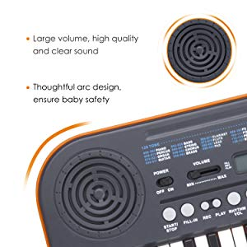 |  | 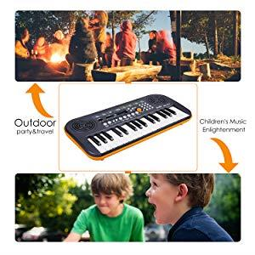
32 key Electronic Organ is an educational and interactive musical instrument. Through playing you learn to recognise 8 Instrument Sounds, 8 Rhythms, 22 prerecorded Melodies, 4 Percussion and 4 Sambha sounds. Kids can make beautiful music, Moveable free mic amplifies child's voice because anything worth saying is worth saying louder, and With many sound Adjust key, each key has a different music. The function list includes 32 key electronic keyboard, 22-Demonstration songs, 8 Rhythms, 8 Tones, 4 Kinds of percussion sound, 4 Samba sounds, Tempo control, Volume Control, Record & Playback function, Sustain & Vibrato function, One key one note & Learn function, Chord control function, External free Microphone, Automotive sleep function. Material:PS ; Battery 9V. Makes a perfect gift to your child.
If you have any enquiry about quotation or cooperation, please feel free to email us at peppermusical@gmail.com or use the following enquiry form. Our sales representative will contact you within 24 hours. Thank you for your interest in our products
https://www.peppermusical.com/electronic-organ/32-keys-keyboard/32-key-mini-electronic-keyboard.html

